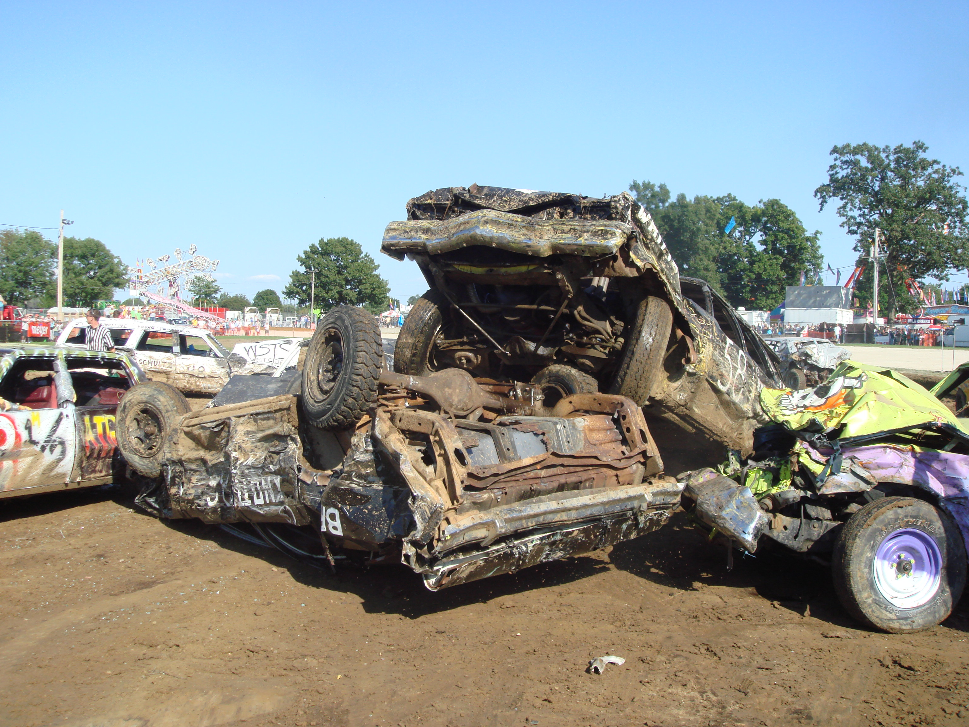**Armageddon On Wheels**

**Sponsorship Package**

[**www.ArmageddonOnWheels.com**](http://www.ArmageddonOnWheels.com)

**List of Events** 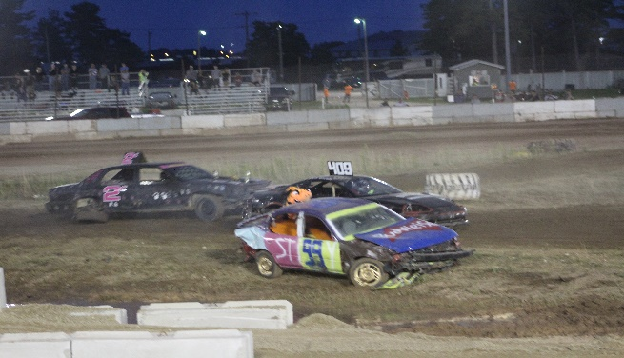

**1 – Bump N’ Run (Off-road demolition derby)**

Bump and run cars in two classes compete for 6 and 10 short laps to finish first. Class #1 is 4/6 Cylinders and Class #2 is 8 cylinders. Anything safe goes in these races and non-aggressive bumping is allowed. The heat race will be 6 short laps and the feature will be 10 short laps. All entrees will race in both the heat and feature races with order randomly selected. See rules for your vehicle.

**2 – School Bus Figure Eight**

School buses race in a Figure Eight Race for 12 laps in one of the last racers of the night. This year we have some short buses, full sized 77 passenger school buses, and some in between. See rules for your bus.

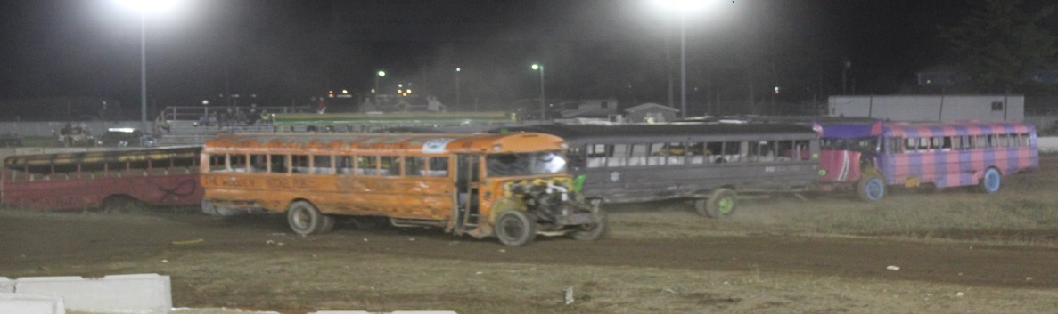

**3 – Dueling Tough Trucks**

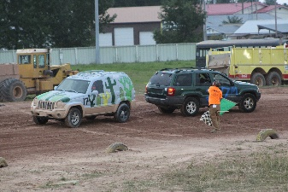Vehicles will race against each other in a double elimination tough truck bracket. (See elimination bracket) This is a non-contact race where the fastest truck will advance. This type of race allows for more visual enjoyment from the crowd as well as trucks are more competitive racing side by side.

**5 – Figure Eight Trailer Race**

Cars, trucks, and vans of all kinds will be pulling trailers in a figure eight race for 10 minutes with order randomly selected. These cars will be pulling two wheeled trailers with boats, hot tubs, campers, etc., but something detachable has to be on the trailer. Anything safe goes on the race track during the 10 minutes of racing, however, **if you hit the driver’s door of another racer, you will be black flagged from the event.**  The most completed laps with trailer still attached will determine placement. See rules for your car.

Armageddon On Wheels Event Sponsorship Package

[**www.ArmageddonOnWheels.com**](http://www.ArmageddonOnWheels.com)

711 Stephenson Avenue

Escanaba, MI 49829

906-280-7502 Jamie Spriks - Director

906-280-7570 Jennifer Spriks - Advertising

**About us**

Armageddon On Wheels began in 2014 when a group of guys came together teaming up with the Upper Peninsula International Raceway and The Delta County Chamber of Commerce to put on a first ever show in the Upper Peninsula at the U.P. State Fair.  This show consisted of a figure eight bus race, bump n’ run, tough trucks and a figure eight trailer race.  After its huge success and being the largest event to come to the U.P. State Fair on a Saturday since 1927 we were invited back to do it again!  This year we will have one event on August 3, 2019 at 7:00 PM at the U.P. State Fairgrounds.

**Mission Statement**

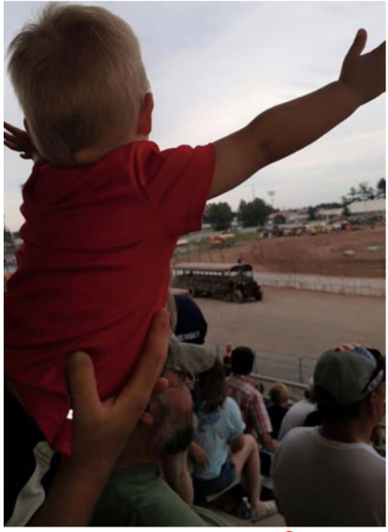We strived last year to put on a one of a kind event that’s never been done in the Upper Peninsula. This event wasn’t easy but after many days and hours of planning it all came together on the day of the show. Our mission is to continue this one of a kind event and put on a big show Saturday, August 3 under the lights at the U.P. State Fair.

**Who Will Attend?**

Last year we attracted people from all over the Upper Peninsula. We strived and pushed to get into different markets such as in Marquette, Houghton, Iron Mountain, Menominee, Madison, WI and even Illinois. Last year we attracted over 5,500 people to the area as far away as Las Vegas, NV that came to Armageddon and this year we want to break our own record. We have more buses, cars and other surprises that will remain surprises. **With sponsorships and support we believe we can attract people as far as Canada, and from different places in the Midwest.**

**Registration and Event Details**

We have met with the Delta County Chamber of Commerce as well as the Upper Peninsula International Raceway and have our date set in stone. We are in the process of pre-registering racers and have already started filling different events. With some extra help we will be able to put on a show that will be appealing to everyone from **8 years old to 80 and everyone in between**. I am confident it will be bigger and better than last year which was of course a huge success on its own.

**Event Sponsorship Packages**

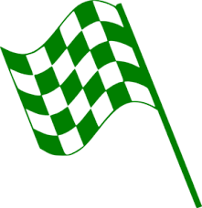 **Green Flag Sponsorship**

**$1500.00**

* Company name and logo prominently displayed at event
* Radio ads four weeks prior to event via RRN Radio Stations
* Sponsor posted on Armageddon’s website and Facebook page
* Sponsor on volunteer t-shirt
* Posters hung in local business’s around the Upper Peninsula with sponsor name
* Sponsor name mentioned during the event
* Free admission to Armageddon On Wheels ( 5 Tickets)



**Checker Flag Sponsorship**

**$ 3000.00**

* Company name and logo prominently displayed at event
* Radio ads four weeks prior to event via RRN Radio Stations
* Sponsor posted on Armageddon’s website and Facebook page
* Sponsor on volunteer t-shirt
* Posters hung in local business’s around the Upper Peninsula with sponsor name
* Sponsor mentioned during the event
* **FIGURE 8 BUS WITH YOUR NAME & LOGO – driver provided if needed**
* **Bus will be in the Gladstone, MI 4th of July Parade & events in area**
* **FREE Admission to Armageddon On Wheels (10 Tickets)**